OCCC Social Media Samples

Twitter

Oakland County has the chance to be a leader on climate justice in Michigan. Urge them to take bold, decisive action at bit.ly/TOCG2020 #TurnOaklandCountyGreen

Stuck at home with nothing to do? Combine social action with social distancing! Sign on to urge Oakland County to lead the fight for climate justice at bit.ly/TOCG2020 #TurnOaklandCountyGreen

Stakeholders all across the county have come together and created a 2020 Oakland County Climate, Jobs and Justice platform. Join the movement and sign on in support today at bit.ly/TOCG2020 #TurnOaklandCountyGreen

Facebook

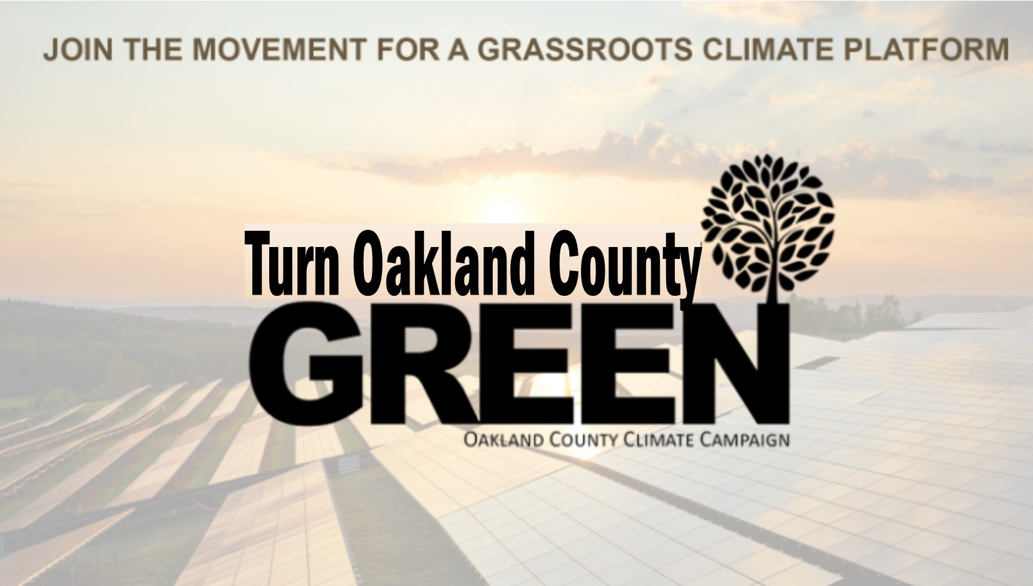

Caption 1: The Oakland County Climate Campaign has developed a platform for climate, jobs and justice that provides the vision needed to protect the world for our grandchildren. It has been endorsed or supported by the League of Conservation Voters, Clean Water Action, Michigan Interfaith Power and Light, the NAACP, Sierra Club, Michigan Coalition for Human Rights, Southeast Michigan Jobs with Justice, and more. Sign on at bit.ly/TOCG2020 to make Oakland County a leader in climate action and protecting our communities.

If you’re interested in getting more involved with the campaign, email Andrew Sarpolis at Andrew.sarpolis@sierraclub.org)

Caption 2: The 2020 Oakland County Climate, Jobs, and Justice Platform is a framework that includes five pillars for our future: climate justice, transit/transportation, clean water, energy justice, and democratic access. It has been endorsed or supported by the League of Conservation Voters, Clean Water Action, Michigan Interfaith Power and Light, the NAACP, Sierra Club, Michigan Coalition for Human Rights, Southeast Michigan Jobs with Justice, and more. Sign on in support at bit.ly/TOCG2020

If you’re interested in getting more involved with the campaign, email Andrew Sarpolis at Andrew.sarpolis@sierraclub.org)

Instagram

Caption: The Oakland County Climate Campaign is a grassroots movement pushing for leadership from Oakland County officials on climate action and justice. Our platform includes five pillars for our future: climate justice, transit/transportation, clean water, energy justice, and democratic access. Sign on to support at bit.ly/TOCG2020 #TurnOaklandCountyGreen

If you’re interested in getting more involved with the campaign, email Andrew Sarpolis at Andrew.sarpolis@sierraclub.org

